**Unit 3 – 6.Further Differentiation Techniques**

**Parametric Differentiation**

To differentiate a function which is defined in terms of a parameter *t*, you need to use the chain rule:

Eg1 A curve has the parametric equations  and . Find

(i)  in terms of the parameter *t*;

(ii) the equation of the tangent to the curve at the point where ;

1. by eliminating the parameter, find the Cartesian equation of the curve.

Eg2 An ellipse has parametric equations  and . Find

(i) at the point with parameter θ;

(ii) the equation of the normal at the point where 

1. by eliminating the parameter, find the Cartesian equation of the curve.

**Exercise 3.6A (1st column)**

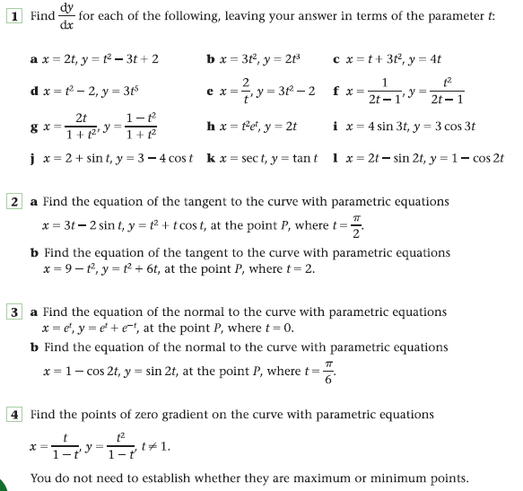

**Answers**

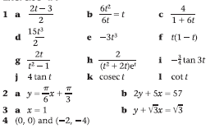

**Implicit Differentiation**



The graph above plots the equation , known as *the folium of Descartes*. This is an example of an implicit function – one that cannot be written with y as the subject. Such functions would pose problems with our current level of calculus knowledge if we were required to find an expression for its gradient. However with a little extension of our chain rule work, implicit functions can be differentiated.

Let’s start with a more straightforward implicit function



in order to derive an expression for we need to differentiate each term with respect to (w.r.t.) *x*, ie:

Differentiating functions of *x* w.r.t. *x* is straightforward. The problem comes when trying to differentiate a function of *y* w.r.t. *x*. This is where the chain rule is used.

Suppose , it follows that 

but if we require , then using the chain rule:

Notice what we have just done – in order to differentiate  w.r.t. *x*, we have differentiated w.r.t. *y* and then multiplied by , i.e.



We can generalise this as follows:

**To differentiate a function of *y* with respect to *x*, we differentiate with respect to *y* and then multiply by **



So returning to our circle:



Often, it is also necessary to employ the product rule in order to complete the differentiation.

Eg3 Find an expression for the gradient function for the folium of Descartes and hence find the coordinates of the stationary points.

**Exercise 3.6B** (1st Column)

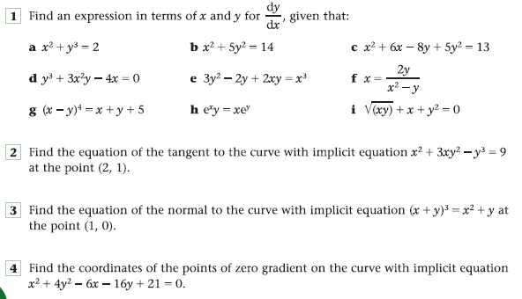

**Answers**

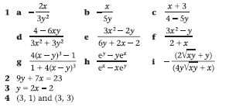

**Differentiating exponential functions (NOT )**

Eg4 Differentiate , where *a* is constant

i.e. if , then 

**Exercise 3.6C**

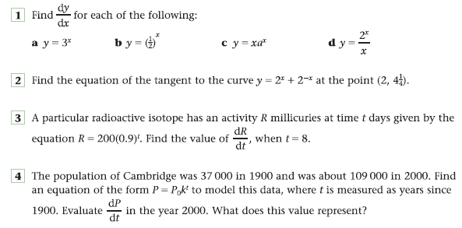

**Answers**

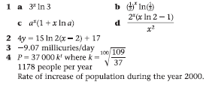

**Using the Chain Rule to link Rates of Change**

A further application of the chain rule enables us to combine various rates of change, to produce a differently related rate of change. This is best illustrated using examples!

Eg5 The radius of a circular inkblot is increasing at a rate of 0.3 cm s-1. Find, in cm2 s-1 to 2 sig figs, the rate at which the area of the inkblot is increasing at the instant when the radius of the blot is 0.8 cm.

Eg6 Given that P = x(x2 + 4)1/2, find dP when x = 2 and dx = 3

dt dt

Eg7 The edges of a cube are of length x cm. Given that the volume of the cube is being increased at a rate of p cm3 s-1, where p is a constant, calculate, in terms of p, in cm2 s-1, the rate at which the surface area of the cube is increasing when x = 5.

**Exercise 3.6D**

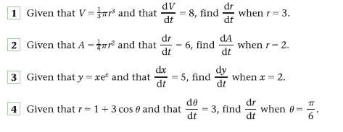

**Answers**

