**8. Differential Equations**

A differential equation is an equation connecting x, y and the differential coefficients, , etc.

For example:  or 

The order of a differential equation is the order of the differential coefficient of highest order in the equation. So the first example above is of first order, the other of second order.

Different approaches are required to solve these equations depending on their complexity. In Unit 3 we only need concern ourselves with first order differential equations whose variables are separable:

Eg1 Find, for , the general solution of the differential equation 

Notice that when we solve a differential equation, we get not just one solution, but a whole family of solutions, as the constant *A* can take any value. This is called the ***general solution*** of the differential equation. If we are given some more information , we can find out which of the possible conditions is the one that matches the situation in the question.

Eg2 Find the particular solution of the differential equation, $\frac{dy}{dx}=y^{2}sinx$ for which *y* = 1 when *x* = 0.

Often differential equations are derived from a scientific context involving rates of change – Newton’s Law of Cooling in Physics, radioactive decay in Chemistry, population growth of bacteria of rabbit colonies in Biology would all be modelled using differential equations.

Eg3 The acceleration of an object is inversely proportional to its velocity at any given time and the direction of motion is taken to be positive. When the velocity is

1ms-1, the acceleration is 3ms-2.

1. Find a differential equation to model this situation.
2. Find the particular solution to this differential equation for which the initial velocity is 2ms-2.
3. In this case, how long does the object take to reach a velocity of 8ms-1?

Eg4 A cold liquid at temperature , where , is standing in a warm room. The temperature of the liquid obeys the differential equation



where the time *t* is measured in seconds.

1. Find the general solution of this differential equation.
2. Find the particular solution for which when .
3. In this case, how long does the liquid take to reach a temperature of ?

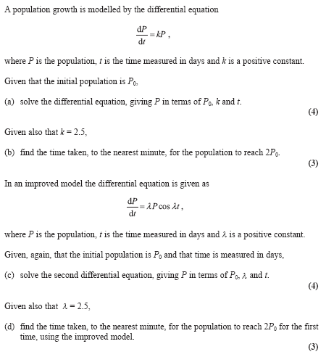Eg5

**Exercise 8.1 (WJEC PURE MATHS PPQs)**

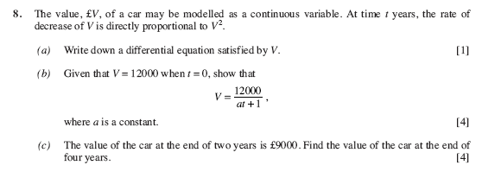

1.

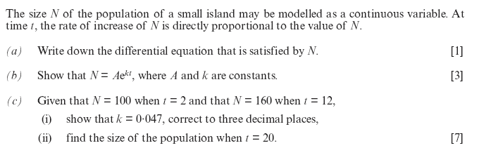2.

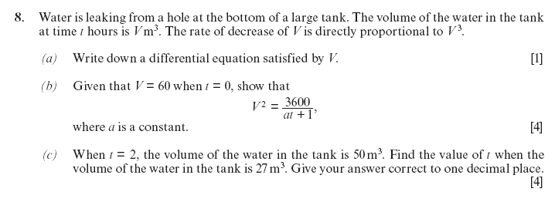

3.

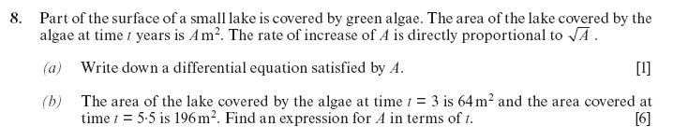

4.

**Exercise 8.2 (WJEC MECHANICS PPQs)**

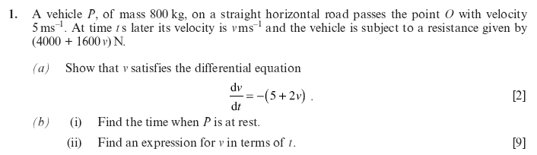

1.

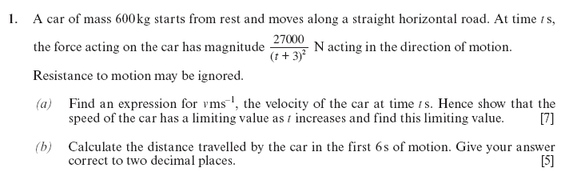

2.

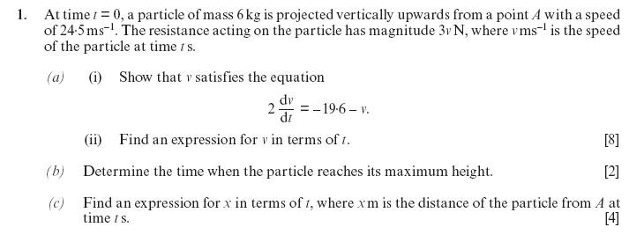

3.