6. Forces

Components of forces

In AS Unit 2 we saw that two forces can be combined into a single force which is called their resultant.

There is a reverse process which consists of expressing a single force in terms of its two components. These components are sometimes referred to as the resolved parts of the force.

It is particularly useful to find two mutually perpendicular components of a force.

The directions may, for example, be horizontal and vertical, or parallel and perpendicular to the surface of an inclined plane.

The component of the force F in any given direction is a measure of the effect of the force F in that direction.

Consider a force F acting at and angle θ to the x-axis as shown below. The components F_{x} and F_{y} being the horizontal and vertical components of F respectively.

Eg1 Find the components F_{x} and F_{y} of the given forces:

Exercise 6.1 Q’s 1 & 2

Eg2 A body of mass 4kg rests on an incline of 35º. Find the component of the weight of the body parallel and perpendicular to the plane.

Exercise 6.1 Q3

Eg3 Find the sum of the components of the given forces in the direction of (i) x-axis (ii) y-axis.

Exercise 6.2 Q’s 4 & 5

Further N2L Problems

Now that we can resolve forces, we can extend the complexity of the situations which require Newton’s second law to solve.

Eg4 A body of mass 4kg has an acceleration a when it is acted upon by a force of which is inclined at 45º to the smooth horizontal surface on which the body rests. By resolving the forces parallel and perpendicular to the plane, calculate the normal reaction between the body and the plane and the acceleration, a, of the body.

Exercise 6.2 Q’s 1 to 5

Eg5 A body of mass on the surface of a smooth plane inclined at 60º is acted on by a horizontal force of 15g N. Calculate the normal reaction of the plane on the body, and the acceleration of the body up the surface of the smooth inclined plane.

Exercise 6.2 Q’s 6 to 9

Rough Surfaces

In the previous examples, motion has taken place on smooth surfaces. In practice this does not happen; all surfaces tend to impede motion. The resistance to motion is an external force acting upon the body, parallel to the surfaces in contact. It will be considered to be a constant force.

Eg6 A body of mass 5kg is released from rest on the surface of a rough plane which is inclined at to the horizontal. If the body takes 3 seconds to reach a speed of 4.9ms⁻¹ from rest, find the resistance to motion which the body must be experiencing.

Exercise 6.2 Q’s 12 to 17

Friction

Place a heavy book on a table and push it lightly with your finger. Nothing happens. The force from your finger is balanced by an equal frictional force in the opposite direction.

Now increase the force P with which your finger is pushing the book. As P increases, so does the frictional force F opposing it. They balance each other, so

Until … the book moves. At that point the frictional force F has reached the greatest value it can take, and it is no longer able to balance P.

So the frictional force F between an object and surface is not constant, but increases as the applied force P increases until the force F reaches a value F_{max} beyond which it cannot increase. The book is then on the point of moving and is said to be in a state of limiting equilibrium.

In our situation with the book, whilst P < F_{max}, the book will not move. When P = F_{max}, the book is in limiting equilibrium (on the point of moving). When P > F_{max}, the book moves.

A frictional force will always act in the direction opposed to motion. If an object is moving, the frictional force will take its greatest possible value.

Coefficient of friction

The magnitude of the maximum frictional force is a fraction of the normal reaction, R. This fraction is called the coefficient of friction (μ) for the two surfaces in contact.

From Wikipedia…

Most dry materials in combination have friction coefficient values between 0.3 and 0.6. Values outside this range are rarer, but teflon, for example, can have a coefficient as low as 0.04. A value of zero would mean no friction at all, an elusive property – even magnetic levitation vehicles have drag. Rubber in contact with other surfaces can yield friction coefficients from 1 to 2. Occasionally it is maintained that µ is always < 1, but this is not true. While in most relevant applications µ < 1, a value above 1 merely implies that the force required to slide an object along the surface is greater than the normal force of the surface on the object. For example, silicone rubber or acrylic rubber-coated surfaces have a coefficient of friction that can be substantially larger than 1.

Eg7 A block of mass 5kg rests on a rough horizontal plane, the coefficient of friction between the block and the plane being 0.6. Calculate the frictional force acting on the block when a horizontal force P is applied to the block and the magnitude of P is (a) 12N, (b) 28N, (c) 36N. Also calculate the magnitude of any acceleration that may occur.

Eg8 A 10kg trunk lies on a rough horizontal floor. The coefficient of friction between the trunk and the floor is . Calculate the magnitude of the force P which is necessary to pull the trunk horizontally if P is applied (a) horizontally, (b) at 30º above the horizontal.

Exercise 6.3

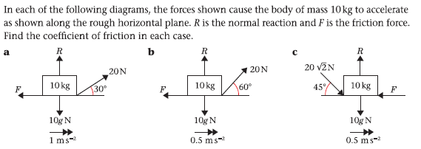
Answers
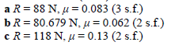

Eg9 A mass of 6kg rests in limiting equilibrium on a rough plane inclined at 30º to the horizontal. Find the coefficient of friction between the mass and the plane.

Eg10 A mass of 0.5kg is resting on a rough plane. The coefficient of friction between the mass and the plane is , and the plane is inclined at angle θ to the horizontal such that . A mass then experiences a force of 6N applied up the plane along a line of greatest slope. Calculate the magnitude of the acceleration of the mass up the slope.

Exercise 6.4

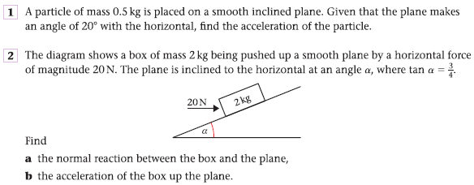
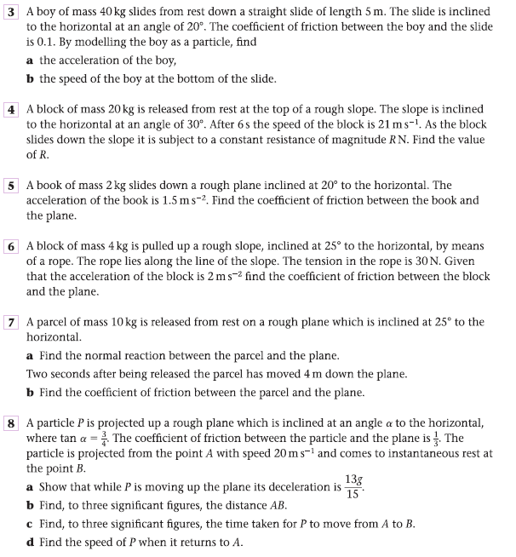

Answers
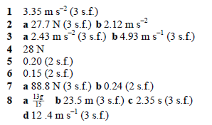

The Effect of N2L on Pulleys

When connected particles pass over a pulley and released, the resulting motion will produce the same acceleration in each body. However, it is not possible to consider the system as a whole as the particles will be travelling in different directions.

A smooth pulley means that the tensions in the string are equal on both sides of the pulley.

If M_{A} > M_{B}

A
B

Eg 11 Two particles of mass 7kg and 3 kg are connected by a light, inextensible string passing over a smooth fixed pulley. Find the acceleration of the particles, the tension in the string and the force exerted on the pulley.

Eg 12 Bodies of mass 3Mkg and Mkg are connected by a light inextensible string which passes over a smooth fixed pulley. With the masses hanging vertically, the system is released from rest. Find the acceleration of the system and the distance moved by the 3Mkg mass in the first 2 seconds of motion. After the 3M kg mass hits the floor 10metres below the point of release, how much farther will the Mkg body travel before beginning to fall again?

Exercise 6.5 Q4

Eg 13 A particle of mass 3kg rests on a rough horizontal table ( = 0.2). It is connected by a light, inextensible string passing over a smooth pulley fixed at the edge of the table to a particle of mass 2kg which hangs freely. Find the acceleration of the system when it is released from rest. Find also the force exerted on the pulley.

Ex 6.5 Q5

Eg 14 A particle of mass Mkg rests on a smooth plane inclined at an angle of 30º to the horizontal. It is connected by a light, inextensible string passing over a smooth pulley fixed at the top of the plane to a particle of mass 4Mkg which hangs freely. Find the acceleration of the system when it is released from rest, the tension in the string and also the force exerted by the string on the pulley.

Ex 6.5 Q’s 6, 7, 9

Exercise 6.5

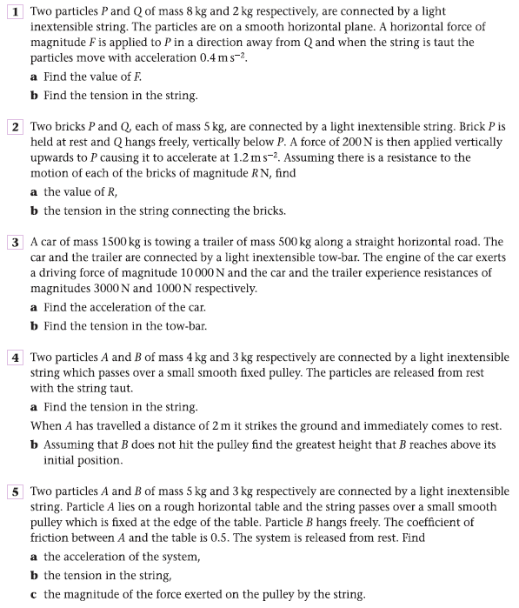

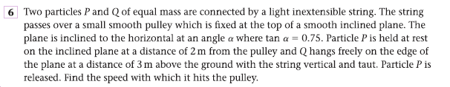

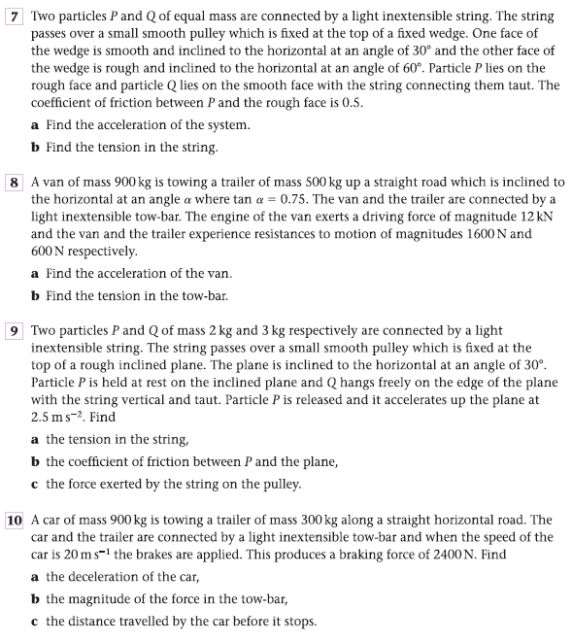

Answers
