1. Probability

A2 Conditional Probability

Conditional probability is the probability of an event occurring given that another event has occurred.

Consider the following GCSE question:

A clown has seven pairs of shoes, one pair in each of the colours of the rainbow. The shoes are kept in a trunk in a dark room. The clown selects two shoes at random.

- What is the probability that the clown selects one left shoe and one right shoe?
- What is the probability of selecting a matching pair of shoes?

This is best approached using a tree diagram

In general, for two events, A and B, the probability of B occurring given that A has already occurred is written as P(B|A). This can be usefully represented on a tree diagram:

This leads to the conditional probability formula for dependent events

P(A ∩ B) = P(A)P(B|A)
which is often more usefully written
$$P\left(B | A\right)=\frac{P(A∩B)}{P(A)}$$
it also holds that
P(A ∩ B) = P(B)P(A|B)

Depending on the nature of the information you are given, problems involving conditional probability can be supported by drawing tree diagrams, Venn diagrams or two-way tables. We need to become familiar with each.

Tree Diagrams

Eg4 Two events A and B occur such that P(A’) = 0.6, P(B|A) = 0.7, P(B|A’) = 0.4
- Represent this information on a tree diagram
- Use your tree diagram to find
  - P(A ∩ B)
  - P(A’ ∩ B’)
  - P(B’|A)

Eg5 Two events A and B occur such that P(B|A) = 0.55, P(B|A’) = 0.5 and P(A) = 0.65
- Represent this information on a tree diagram
- Use your tree diagram to find
- P(A ∩ B)
- P(B)
- P(A|B)

Eg6 The turnout of spectators at a motor rally is dependent on the weather. On a rainy day the probability of a big turnout is 0.4, but if it does not rain, the probability of a big turnout increases to 0.9. The weather forecast gives a probability of 0.75 that it will rain on the day of the race.
- Draw a tree diagram to represent this information.
- Find the probability that
  - there is a big turnout and it rains
  - there is a big turnout

Exercise 1
- A and B are two events such that P(A|B) = 0.1, P(A|B’) = 0.6 and P(B) = 0.3
- Draw a tree diagram to represent this information
- Find
  - P(A ∩ B)
  - P(A ∩ B’)
  - P(A)
  - P(B|A)
  - P(B|A’)
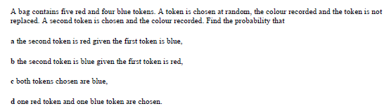

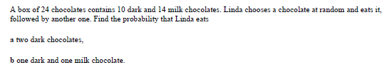

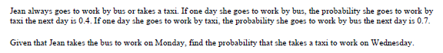

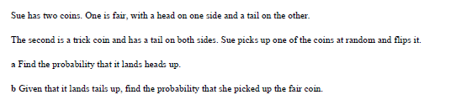

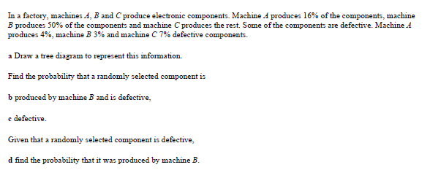

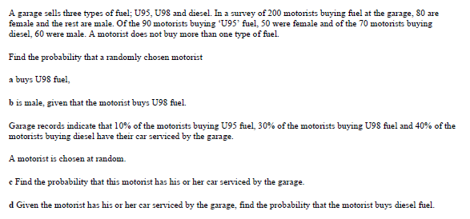

Numerical Answers
(1b) (i) 0.03 (ii) 0.42 (iii) 0.45 (iv) 1/15 (v) 27/55 (2a) 5/8 (b) ½ (c) 1/6 (d) 5/9

(3a) 15/92 (b) 35/69 (4) 0.36 (5a) ¼ (b) 1/3

(6b) 0.015 (c) 0.0452 (d) 0.332 (7a) 0.2 (b) 0.5 (c) 49/200 (d) 4/7

Conditional Probability & Venn Diagrams
Eg7 C and D are two events such that P(C) = 0.2, P(D) = 0.6 and P(C|D) = 0.3. Find
- P(D|C)
- P(C’ ∩ D’)
- P(C’ ∩ D)

Eg8 Let A and B be events such that P(A) = 0.3, P(B) = 0.4 and P(A ∪ B) = 0.5. Find
- P(B|A)
- P(B|A’)
- P(A)P(B|A) + P(A’)P(B|A’)
Comment on your answer to (c)

Eg9 A and B are two events such that P(A|B) = 0.1, P(A|B’) = 0.6 and P(B) = 0.3. Find
- P(A ∩ B)
- P(A ∩ B’)
- P(A)
- P(B|A)
- P(B|A’)

Exercise 2
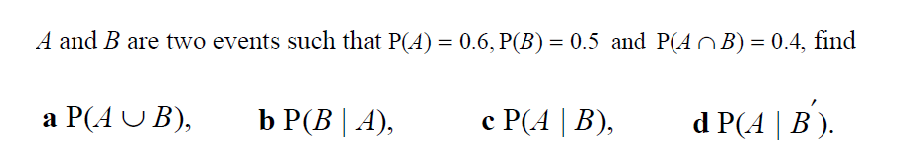
1.

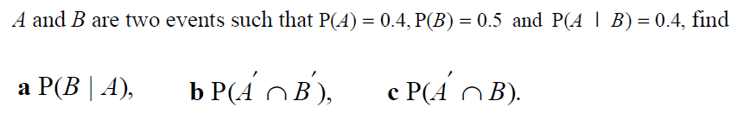
2.

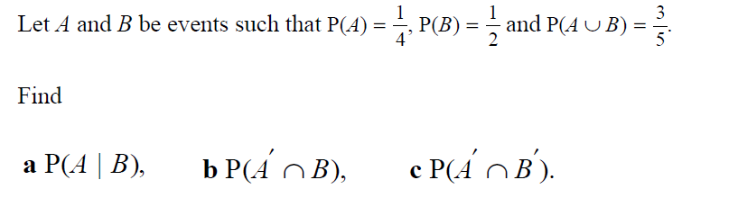
3.

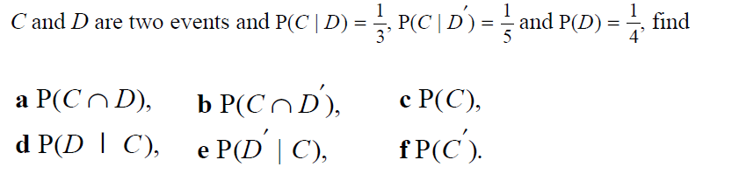
4.

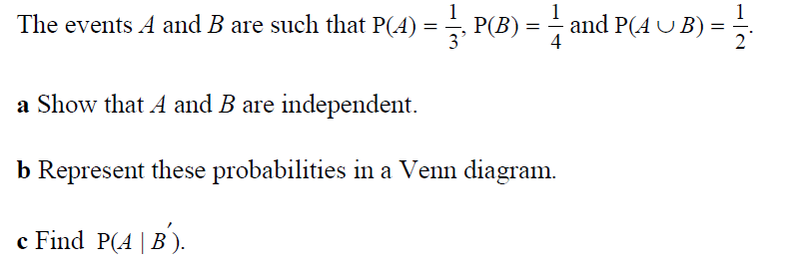
5.

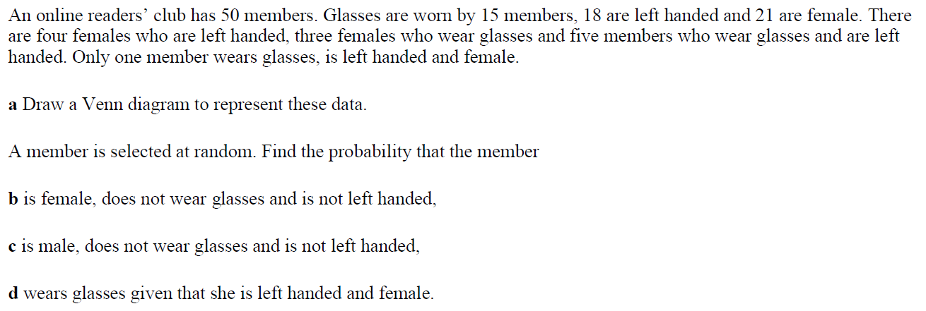
6.

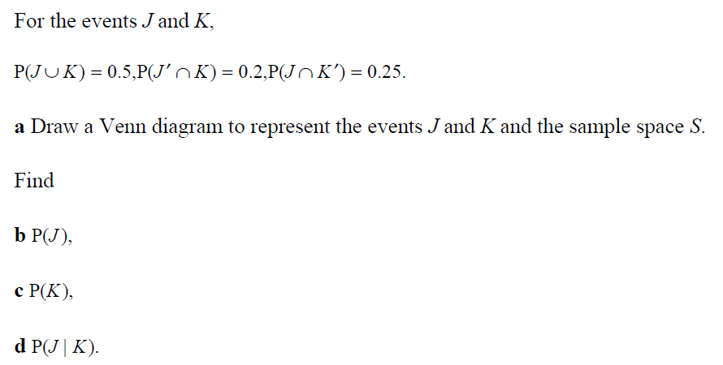
7.

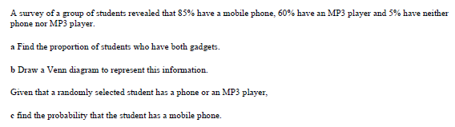
8.
.
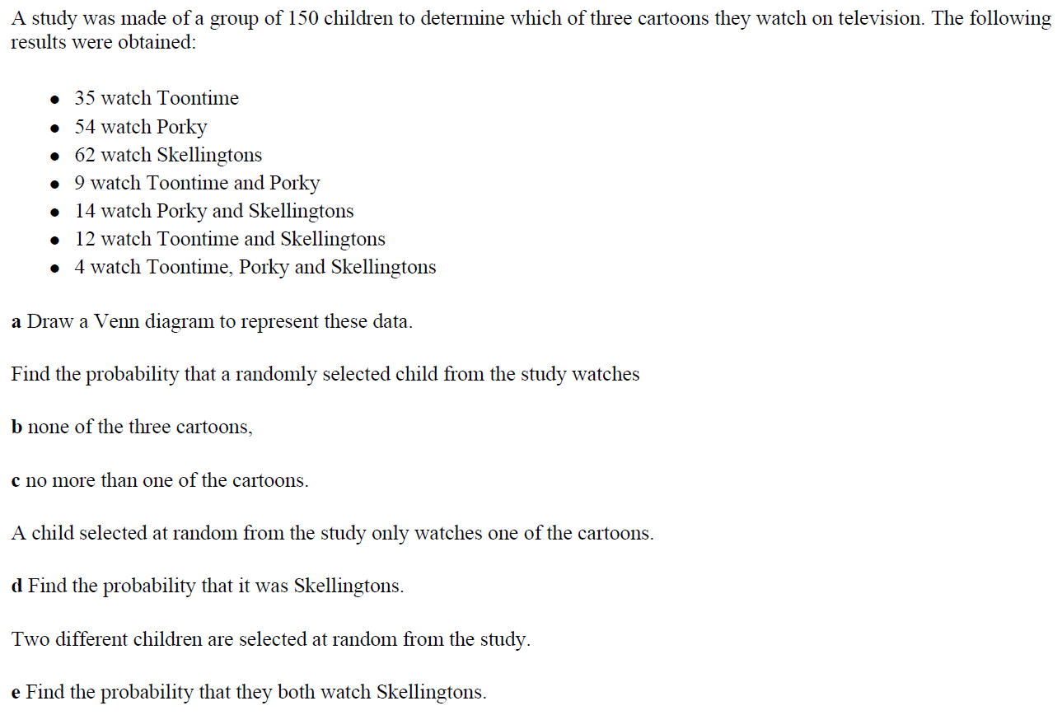
9.
Numerical Answers
(1a) 0.7 (b) 2/3 (c) 0.8 (d) 0.4 (2a) 0.5 (b) 0.3 (c) 0.3 (3a) 0.3 (b) 0.35 (c) 0.4

(4a) 1/12 (b) 3/20 (c) 7/30 (d) 5/14 (5c) 1/3 (6b) 0.3 (c) 0.14 (d) 0.25

(7b) 0.3 (c) 0.25 (d) 0.2 (8a) 0.5 (c) 17/19 (9b) 0.2 (c) 0.82 (d) 40/93 (e) 0.169

Conditional Probability & Two-way tables

Eg10 In a college there are 100 students taking A level French, German or Spanish. Of these students, 64 are female and the rest are male. There are 50 French students of whom 40 are female and 30 German students of whom 10 are female.

Find the probability that a randomly chosen student
- is taking Spanish
- is male, given that the student is taking Spanish

College records indicate that 70% of the French students, 80% of the German students and 60% of the Spanish students have applied for University.

A student is chosen at random.
- Find the probability that this student has applied for University.
- Given that the student had applied to University, find the probability that the student is studying French

If the information is provided in terms of percentages, care must be taken when considering the probabilities:

Eg11 In a town 40% of the people are male
20% of males are left-handed
26% of the people in the town are left-handed

A person is selected at random. Given that this person is a female, what is the probability that she is left-handed?

Exercise 3

1. Debbie counts the videos and DVDs she has and places them into categories.

 | Videos | DVDs | TOTAL
Film | 43 | 16
Comedy |  | 5 | 17
Sport | 21
TOTAL |  | 24 | 100

a) Complete the table above.

One of the items is chosen. Calculate the probability of choosing

b) a DVD.
c) a comedy on video.
d) it being sport, given that it is a dvd
e) it is a video, given that it is not a film

2. Jamie investigated hair and eye colour.

 | Fair hair | Dark hair | TOTAL
Blue eyes | 8 |  | 13
Other |  | 10
TOTAL | 15 | 15

a) Complete the table above.

One of the people is chosen. Calculate the probability of choosing

b) someone with blue eyes.
c) someone with fair hair and blue eyes.

Given that a person with dark hair is chosen. Calculate the probability of

d) them having blue eyes.
e) them not having blue eyes.

3. A travel agent recorded the bookings made on one Saturday.

 | France | Spain | Germany | TOTAL
Car/Ferry | 15 | 8 |  | 28
Plane
TOTAL | 18 | 14 |  | 40

a) Complete the table above.

One of the bookings is chosen. Calculate the probability of choosing

b) a booking for Germany.
c) it being to France given that it is by plane
d) a ferry journey, given it is to Germany

4. Carol records some cars that pass by her house.

 | Volvo | Renault | Ford | TOTAL
Grey |  | 9 | 14 | 31
Red | 4 | 11 |  | 23
Blue
TOTAL | 12 |  | 25 | 60

a) Complete the table above.

One of the cars is chosen. Calculate the probability of choosing

b) a red car.
c) a Volvo given that it is a grey car
d) it being blue given that it is a Ford

5. An electrical store records the following information.

 | Under 21 | 21 -45 | Over 45 | TOTAL
Satellite | 48 |  | 19 | 90
Terrestrial | 28 |  |  | 60
Cable |  |  | 86
TOTAL | 97 |  | 116 | 300

a) Complete the table above.

One of the records is chosen. Calculate the probability of choosing

b) someone under 21 with cable.
c) them not having cable given they are over 45

6. Put the following information into a two-way table.

Ford – Blue Ford – Red Rover – Silver
Vauxhall – Red VW – Blue Rover – White
Vauxhall – White Ford – Green VW – Silver
Ford – Blue Nissan – White VW – Blue
Ford – Red Ford – Green Ford – Silver

Numerical Answers
(1b) 24/100 (c) 12/100 (d) 3/24 (e) 33/41

(2b) 13/30 (c) 8/30 (d) 5/15 (e) 10/15

(3b) 8/40 (c) 3/12 (d) 5/8

(4b) 23/60 (c) 8/31 (d) 3/25

(5b) 21/300 (c) 30/116

A2 Unit 4 Assignment#1 – Probability Due 30/09/19
