1. Probability

AS Recap – the theory for the A2 unit builds upon the following Y12 work

Venn Diagrams and Set Notation

For two events A and B

- the event that A or B or both occur is called the UNION of A and B, which is written

- the event that A and B occur is called the INTERSECTION of A and B, which is written

- the event that A does not occur is called the COMPLEMENT of A, which is written

- the event that A is a SUBSET of B, for example A = {Hearts} B = {red cards} is written

Representing information on Venn diagrams can often help when solving some probability problems.

Eg1 Shade the following Venn diagrams to correctly represent the given events, A and B:
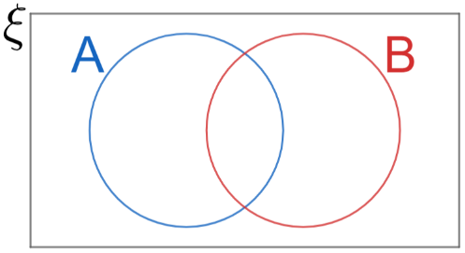
- A

- B’

- A ∩ B

- A ∪ B

- A ∩ B = ∅

- A ∩ B’

- A’ ∩ B

- A ∪ B’

- A’ ∪ B

- (A ∩ B)’

- (A ∪ B)’

- (A ⊃ B)

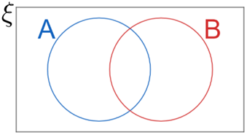
- A’ ∪ B’

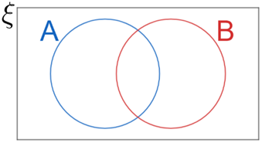
- A’ ∩ B’

Using some of the Venn diagrams above, identify two set relationships which are equivalent:

The Addition Law for Mutually Exclusive Events

If events A and B are MUTUALLY EXCLUSIVE then event A can happen OR event B can happen but they cannot both happen. (Venn diagram (e) ABOVE).

In terms of probability this means

P(A ∪ B) = P(A) + P(B)

The Generalised Addition Law

This links the probability of the intersection with the probability of the union of two events A and B

P(A ∪ B) = P(A) + P(B) – P(A ∩ B)

Eg2 Consider the following GCSE PPQ

Multiplication Law for Independent Events

When an event has no impact on another event, they are said to be independent events. For such events A and B, the following applies:
P(A ∩ B) = P(A) × P(B)

Eg3 Events A and B are such that P(A) = 0.3, P(B) = 0.2, P(A ∪ B) = 0.44
- Show that A and B are independent
- Calculate the probability of exactly one of the two events occurring.

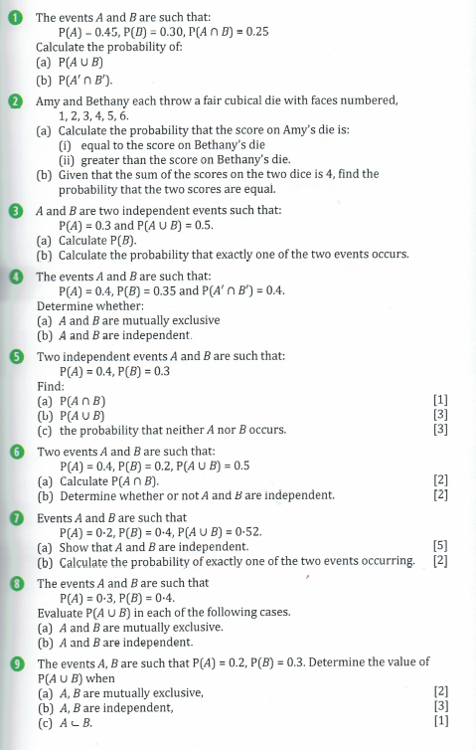
Numerical Answers
(1a) 0.5 (b) 0.5 (2ai) 6/36 (ii) 15/36 (b) 1/3 (3a) 2/7 (b) 29/70 (5a) 0.12 (b) 0.58 (c) 0.42

(6a) 0.1 (7b) 0.44 (8a) 0.7 (b) 0.58 (9a) 0.5 (b) 0.44 (c) 0.3

PPQs

AS U2 June 2018

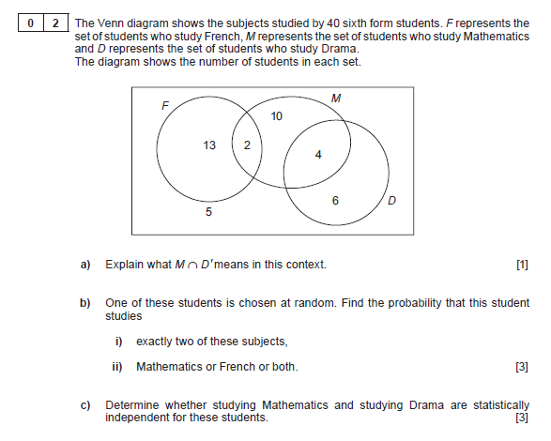

AS U2 June 2019

