Pie Charts

Drawing them
- You need to know how many data items (often people) the pie chart has to represent.

- The whole pie chart has $360°$. Find out how many degrees each (person) gets: $360÷number of \left(people\right)$

- To work out the size of each slice, multiply the angle found above by the number of (people) in each category. Repeat for each slice.

- Remember to mark an initial zero line on the pie chart and then measure the first angle. Draw and label your first slice. Now move the zero line on your angle measurer to the start of the next slice. Measure, draw, label and repeat.
Reading from them
- To write the size of a slice as a fraction of the pie, measure the angle at the centre of the slice and write $\frac{size of slice°}{360°}$

- To work out how many (people) this slice represents, you multiply the fraction found above by the total number of data items (people) that the whole pie chart represents.
Comparing them
- If you are asked to compare information on two pie charts, DO NOT use words like ‘more’ or ‘less’ unless you know that the pie charts each represent the same totals of data items, or you have actually calculated the number represented by each slice. Otherwise you can only say ‘a larger proportion’ or ‘a smaller proportion of’ when comparing.

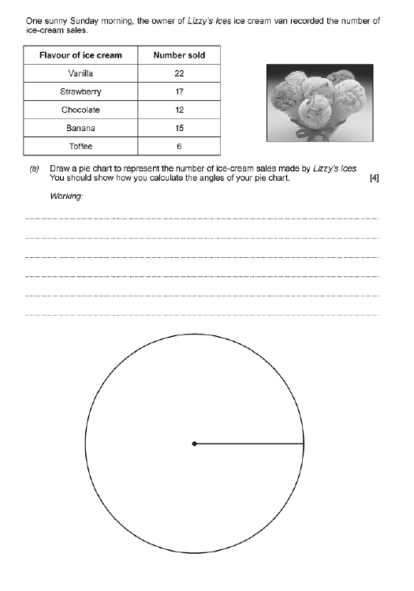
PPQs

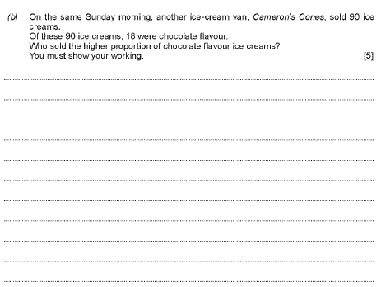

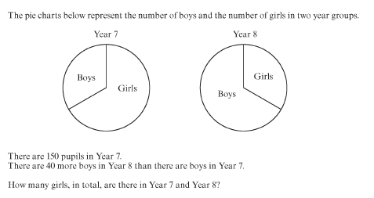

[5]

