Bearings – Constructions - Loci

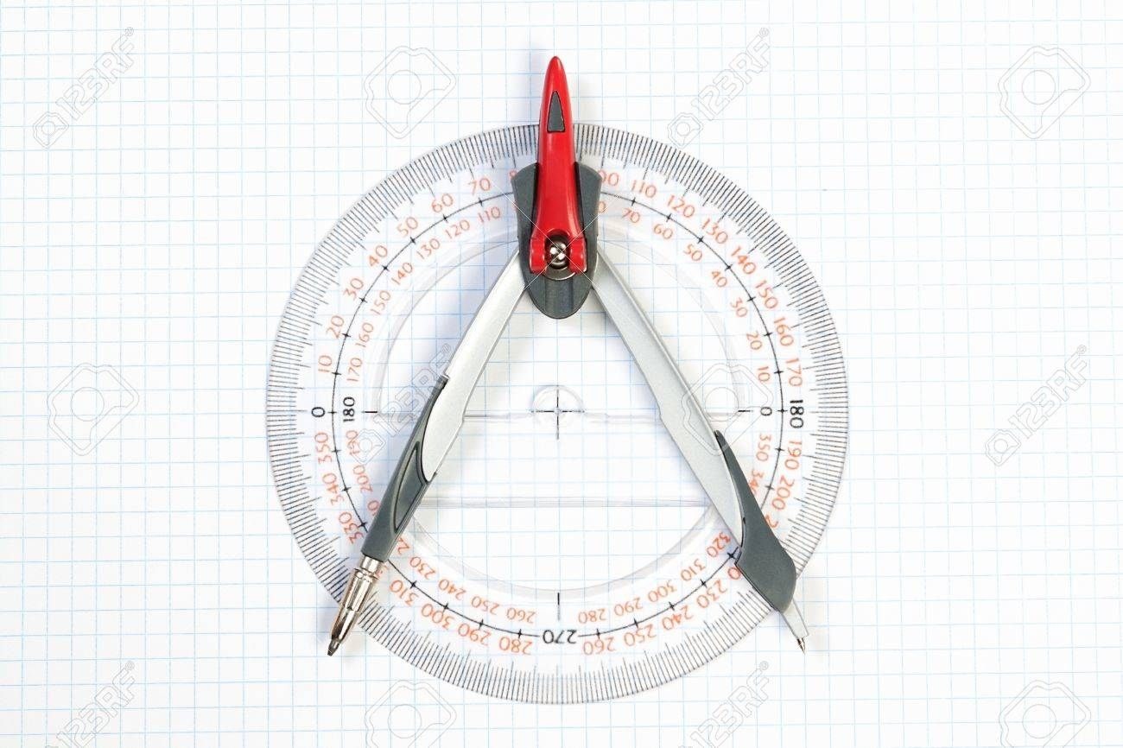

Using your measuring kit!

Three-figure Bearings

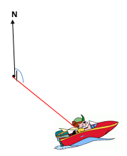
- These are used, along with distance to describe the location of an object from a point.

- The direction is always measured in a clockwise direction from North.

- The bearing of A from B means that you are standing at B and measuring the turn you make from pointing North to pointing at A.
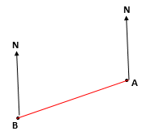

- If the measured angle is less than 100º, a zero is placed in front to make a three digit number. So an measured angle of 65º would be a bearing of 065º.

- Because the North-South direction is always the same, the properties of parallel lines can be used to work out angles.

For example, if the bearing of A from B is 065º, we can work out the bearing of B from A (the back-bearing) without measuring.

GCSE Numeracy November 2016
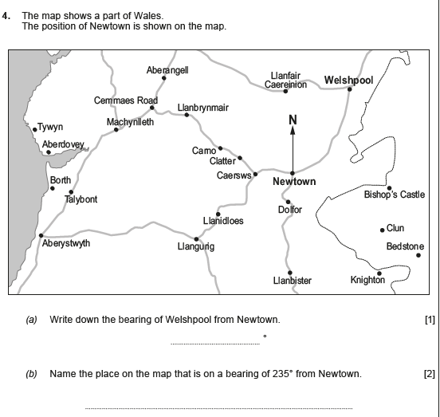

GCSE Maths November 2017
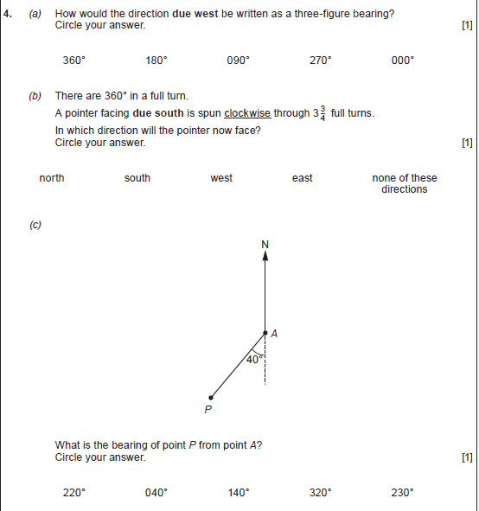

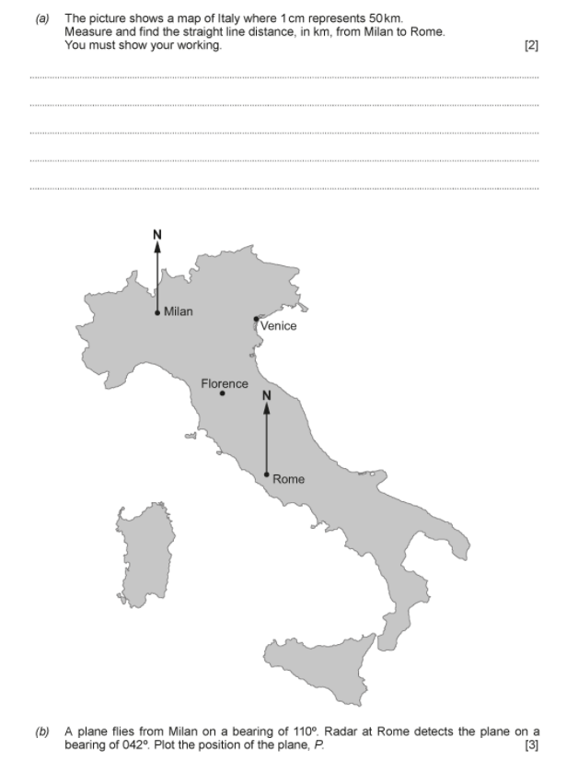

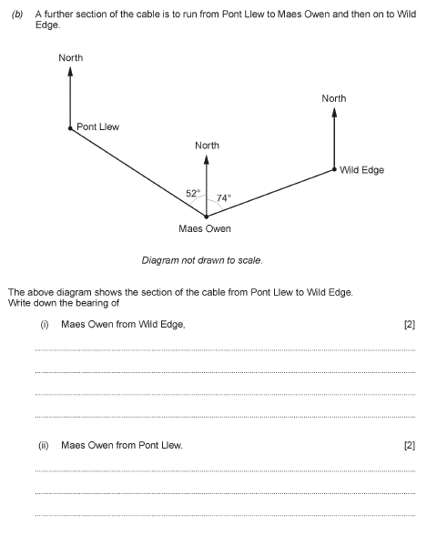

Accurate Drawing

Bisect the following lines

Bisect the following angles

Construct a 60º angle at A
A

A

A

A

Construct a 30º angle at B
B

B

Construct a 90º angle at C

C
C
Complete an accurate drawing of triangle ABC in which AB = 10.5cm, angle BAC = 67º and
BC = 11cm.

Measure and record the size of angle ACB:__________

Complete an accurate drawing of triangle PQR in which PQ = 10.5cm, PR = 9cm and
QR = 12cm.

Measure and record the size of angle PRQ:__________

GCSE Maths November 16
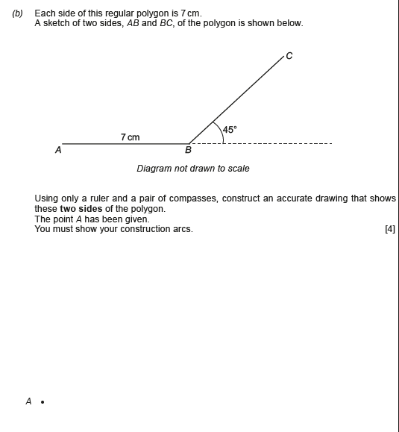

Loci

- A locus is a path which is formed by a point that moves according to some rule. The plural of locus is loci.

- They are used to identify areas that meet given criteria, such as a given distance from a point or halfway between two lines.

- Loci need to be constructed using standard techniques already met – circle, perpendicular bisector and angle bisector.

- Once the loci have been drawn, the appropriate region has to be found and shaded by interpreting the language of the criteria such as at least, at most, no further, within, equidistant…

- Locus of a path equidistant from a point – circle

Draw the path which is exactly 2cm from A

A
•

Shade the region which is at least 2cm from A

- Locus of a path equidistant from two points – perpendicular bisector

Draw the path which is exactly the same distance from A and B
A
•

•
B
Shade the region which is closer to B than to A
- Locus of a path equidistant from a line – parallel line

Draw the path which is exactly 2cm from the line AB

A

B
Shade the region which is at most 2cm from AB

- Locus of a path equidistant from two lines – angle bisector

Draw the path which is exactly the same distance from the lines AB and BC

C
B
A

Shade the region which is further from AB than BC

GCSE Numeracy June 17
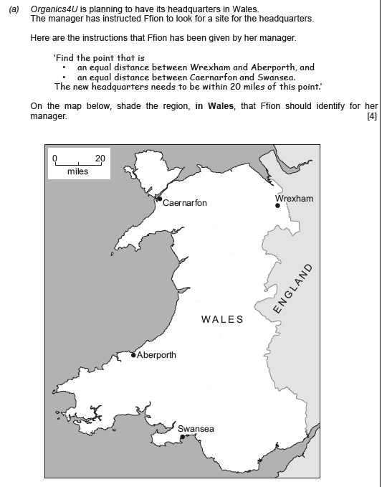

GCSE Numeracy November 16
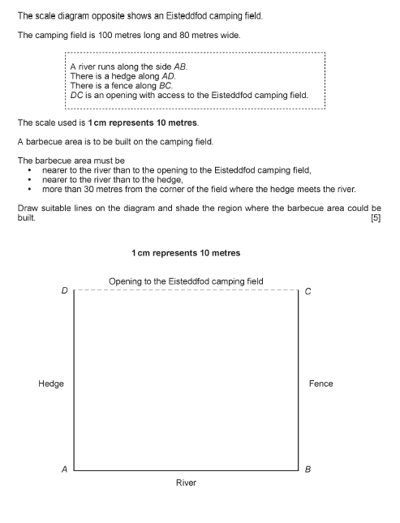

GCSE Numeracy November 2017
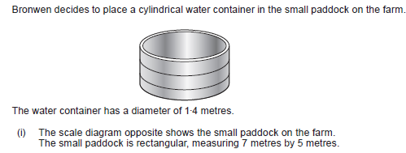
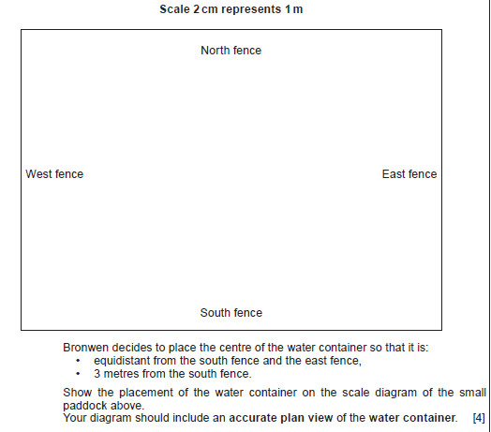

For printable copies of this workbook, or more GCSE questions on bearings, constructions and loci, many with video solutions click on the QR code below or go to

www.tinyurl.com/PembMathWorkshop

For practising other topics visit
www.jonesthesum.co.uk

